Microscopy Practical Worksheet
Name:
Date:
Institution:
- (1 pt) Fill in the following image with the appropriate components. Keep in mind the components themselves are inside the microscope casing.
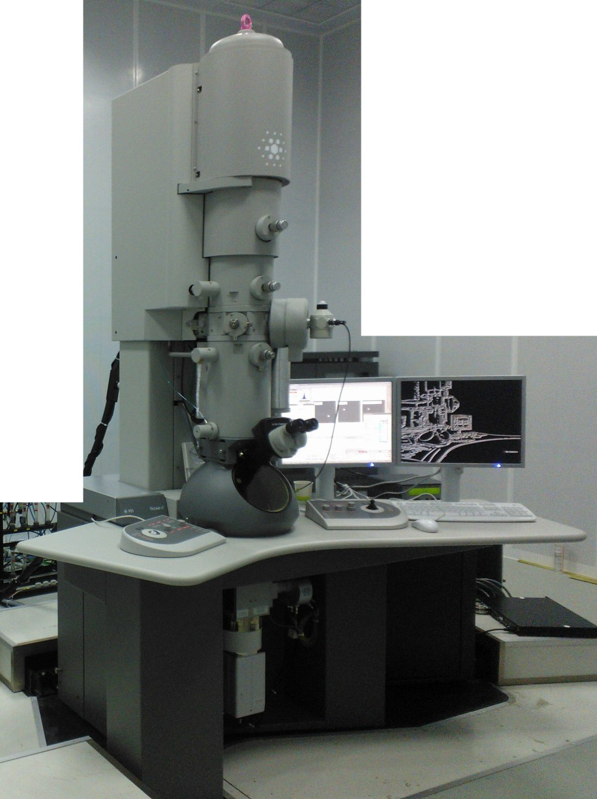

- (3 pts) Describe the term “beam coherence” and explain why it is important. What effects beam coherence?
- (3 pts) What components in the microscope are used to align the electron beam? Describe the “gun tilt” and “gun shift” alignments that were performed. You may write it out or draw a picture.

- (3 pts) Describe the two types of astigmation that were demonstrated and how they were corrected.

