Plunge Freezer/Cryo Sample Preparation Practical Worksheet
Name:
Date:
Institution:
- (1 pt) Fill in the following images with the appropriate components.
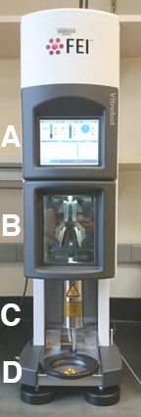
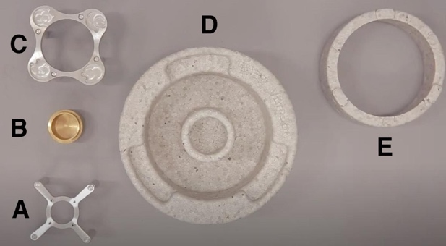

- (3 pts) Describe the process of vitrification for cryoEM, and outline how it is accomplished using a plunge freezer?
- (3 pts) Compare and contrast the purpose of glow discharging for negative stain vs cryogenic grid preparation.

- (3 pts) Describe the how blot-free vitrification techniques may assist with specimen preparation.

