Name ______________________ # of grids dropped off ______________
LDAP username ______________ # of grid boxes dropped off __________
PI & Institute ________________ Gridbox description ________________
Today’s date ________________ Krios# __________________________
Krios session date(s) __________

Krios grid drop off checklist

- I understand that all grids will be clipped and loaded following the SEMC numbering system (see image below)
  - Yes
  - No

- Are we clipping your grids?
  - Yes
  - No - Make sure that you have properly label your box (see image below). All users are responsible for proper labeling of their grid boxes.
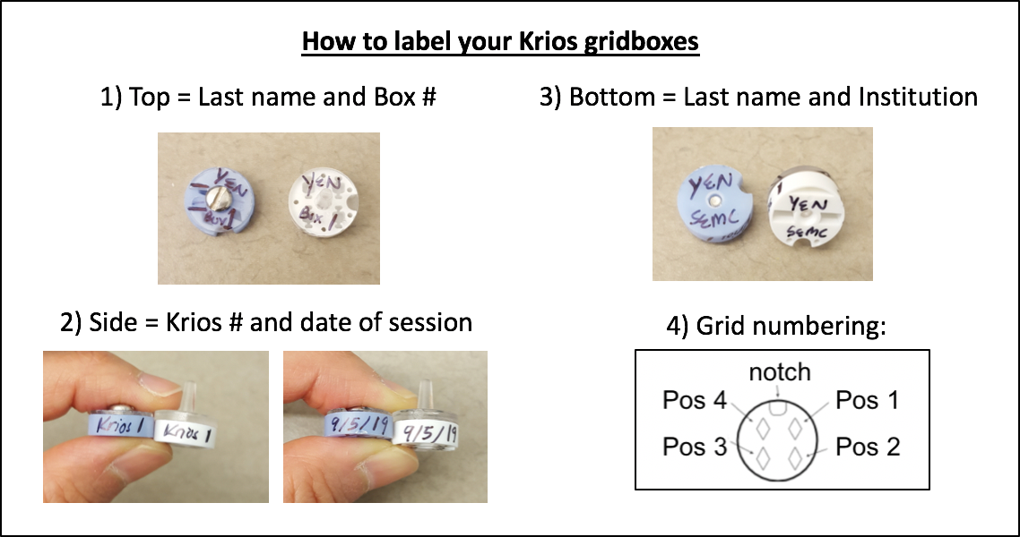

___________________________________________________________________________________________

- If you are bringing more grids than we will be clipping, do you understand that remaining grids will be stored in the “Saved Grids” puck?
- Do you understand that ALL GRIDS will be rescued from the krios and transferred to our “Saved Grids” puck for 2 weeks only!

_________________________________________________________________________________________
Print name and signature (USER) Date
_________________________________________________________________________________________
Print name and signature (STAFF) Date
----------------------------------------------------------------------------------------------------------------------------------------------------
Staff Use Only

# of grids clipped _______ # of unclipped grids _______ clipped by _______________ date _______________

Krios pre-session questionnaire:
1. Who are the assigned users for the session?
Full name: ______________________________________________________________________________
Email address: ___________________________________________________________________________
Phone number: ___________________________________________________________________________
University: ______________________________________________________________________________
PI/Lab: _________________________________________________________________________________
LDAP username: __________________________________________________________________________
2. Which scope are you collecting on and what are your data collection dates:
Krios #_______________First available for SEMC Krios queued access______________________________
Start date (mm/dd/yy) and time (hh:mm): ___________________Krios queued access - TBD_____________
End date (mm/dd/yy) and time (hh:mm): ___________________ Krios queued access - TBD _____________
3. What project are you collecting under for this session? If you have not registered the project yet, you can do so here. (https://deon.nysbc.org/project/submit/)
Project name:_____________________________________________________________________________
4. Dose rate and frame rate (circle one):
K3 = 30 e⁻/pixel/sec dose rate, 50 ms/frame
Other, please specify: _______________________________________________________________________
5. Pixel size (circle one):
~1.1 Å/pixel (standard)
Other, please specify: _______________________________________________________________________
6. K3 camera acquisition mode (circle one):
counting (standard) super-resolution
7. Do you understand that alignments start at the beginning of your session? Alignments may take a significant portion of time depending on the settings desired. Circle one:
Yes, I understand No, I do not understand
8. Have you registered a Globus account for data transfer? Click here (http://semc.nysbc.org/documentation/) for more information..
Yes No (ask emg staff to assist in making one during your session)

