Name _____________________________ # of grids dropped off ____________________
LDAP username _____________________ # of grid boxes dropped off ________________
PI & Institute ________________________ Gridbox description ______________________
Today’s date ________________________ Glacios session date(s) ___________________

Glacios grid drop off checklist

- I understand that 1 box containing 4 grids will be clipped and loaded following the SEMC numbering system (see image below)
  - Yes
  - No

- What is this a screening session for?
  - An upcoming Krios session that has a confirmed date
  - General screening for grid quality
  - Data Collection

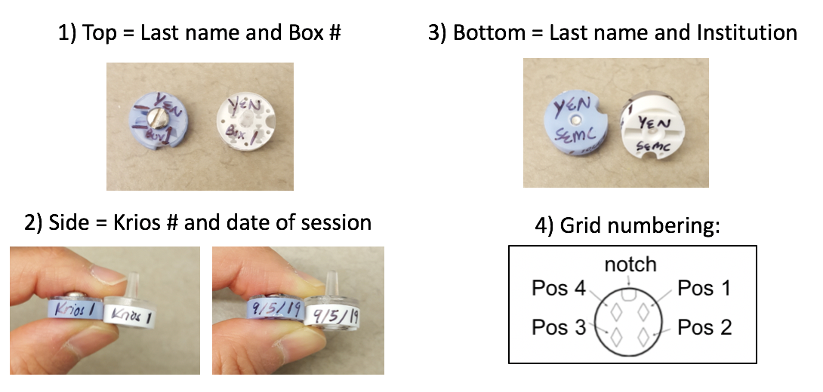
__________________________________________________________________________________________

- If you are bringing more grids than we will be clipping, do you understand that remaining grids will be stored in the “Saved Grids” puck?
- Do you understand that ALL GRIDS will be rescued from the Glacios and transferred to our “Saved Grids” puck for 2 weeks only!

_________________________________________________________________________________________
Print name and signature (USER) Date
_________________________________________________________________________________________
Print name and signature (STAFF) Date
----------------------------------------------------------------------------------------------------------------------------------------------------
Staff Use Only

# of grids clipped _______ # of unclipped grids _______ clipped by _______________ date ______________

